全国2009年10月自学考试

高级英语试题
课程代码：00600
请将答案填在答题纸相应位置上，全部题目用英语作答(英译汉题目除外)

I. The following paragraphs are taken from the textbooks, followed by a list of words or expressions marked A to X. Choose the one that best completes each of the sentences and write the corresponding letter on your Answer Sheet. One word or expression for each blank only. (12 points, 0.5 point for each)
So at least the historical evidence seems to suggest. When I was graduating from college, my
1 also found the world in a mess. The economic machinery had 2 down almost everywhere: In this country 3 a quarter of the population was out of work. A major war seemed all too 4 . As a college newspaper editor at that time, I protested 5 this just as vehemently as student 6 are protesting today.
But today she passed the baker’s by, climbed the 7 , went into the little dark room—her room like a cupboard—and sat down on the red eiderdown. She sat 8 for a long time. The box 9 the fur came out of was 10 the bed. She unclasped the necklet quickly; quickly, 11 looking, laid it inside. But when she put the 12 on she thought she heard something crying.
The Watts-as-a-way-station mentality has a firm hold on 13 those who remain and those who leave. Such as 14 is, the ghetto is regarded as 15 place to make a career for those who have a future. Without 16 , the prime American values underscore the 17 . Negroes, inside it or out, and whites too, behave toward the 18 like travelers.
I know that American technical genius, and 19 of all the moon landing, seems to give the 20 to too summary a condemnation of the 21 system, but there is more to education 22 the segmental equipping of the mind. There is that transmission of the value of the 23 as a force still miraculously fertile and moving—mostly 24 from American education at all levels.
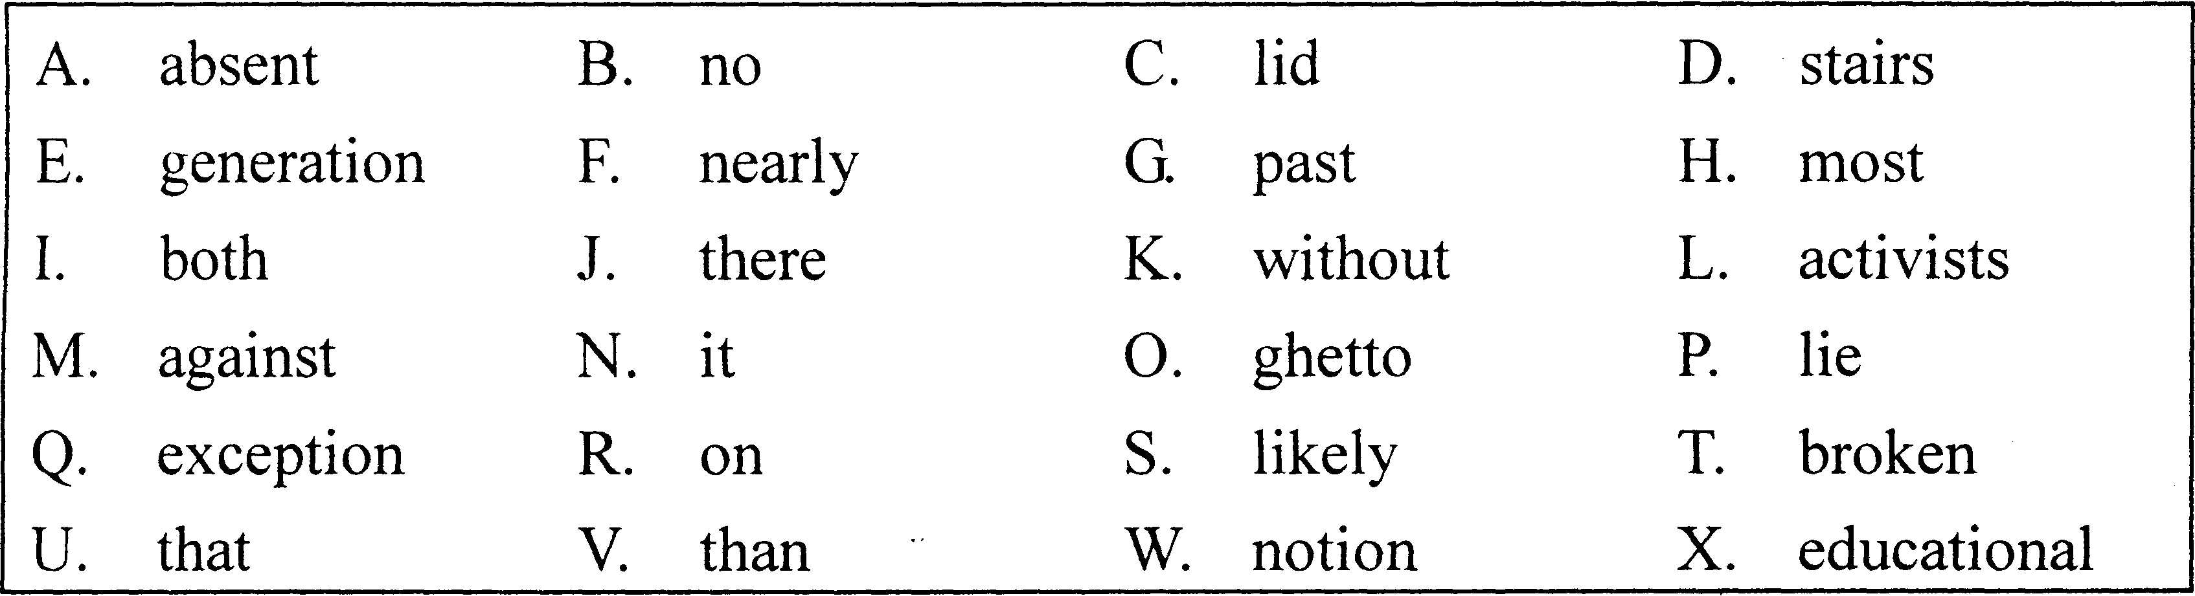
II. In this section, there are fifteen sentences taken from the textbooks with a blank in each, followed by a list of words or expressions marked A to X. Choose the one that best completes each of the sentences and write the corresponding letter on your Answer Sheet. One word or expression for each blank only. (15 points, 1 point for each)
25. Like all artists, these rock musicians _____ feelings and beliefs that help us see and form our own.
26. If you don’t do what the doctor says you’ll have to go to the hospital, the mother admonished her _____.
27. I hope that the example of my _____ will convince other women to get into politics—and not just to stuff envelopes, but to run for office.
28. There was a little path beside the rocky road, and Mrs. Flowers walked _____ swinging her arms and picking her way over the stones.
29. It has become _____ to think that, like fast food, fast ideas are the way to get to a fast-moving, impatient public.
30. All skilled work can be pleasurable, provided the skill _____ is either variable or capable of indefinite improvement.
31. She frowned, conscientiously worrying over what _____ he might secretly be longing for which she had been too busy or too careless to imagine.
32. When salesmen are doing well, there is pressure upon them to begin _____ better, for fear they may start doing worse.
33. Television also provides a wide _____ of opinion by setting up four or five experts and letting them knock each other down.
34. I guess before we’re _____ she may have something more serious than preserves to worry about.
35. She brought a cigarette out of her apron pocket and tucked it deep into one _____ of her mouth, the way she did when something pleased her.
36. Except for some exclusive clubs in London, there were _____ occasions where racial lines were drawn.
37. Undoubtedly the desire for food has been, and still is, one of the main causes of great _____ events.
38. At the same time, of course, the producer must do his bit by producing nothing but the most perishable _____.
39. The northern wind blows viciously today, and there’s no _____ heating to turn on, but it will be pleasant when the wind drops.
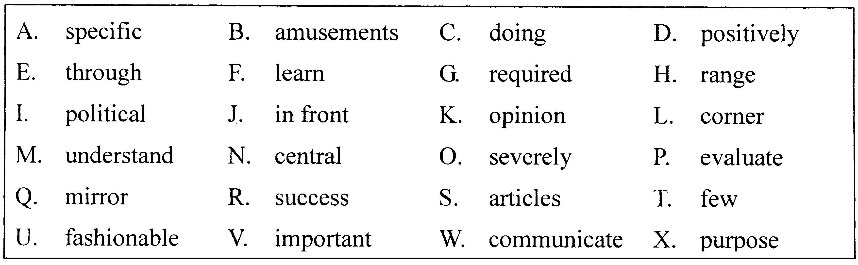III. Each of the following sentences is given two choices of words or expressions. Choose the
right one to complete the sentence and write the corresponding letter on your Answer Sheet. (15 points, 1 point for each)
40. His _____ and unwillingness to learn from others prevent him from being an effective member of the team.
A. arrogance B. advantage
41. We must try to create a more caring, more _____ society.
A. compassionate B. competitive
42. It was _____ and she did not know enough to analyze each problem properly.
A. encouraging B. exhausting
43. Although each TV series will be rated on the basis of its usual content, the ratings can _____ from week to week.
A. flow B. fluctuate
44. This _____ factor means that there is often a connection in appearance and temperament between parents and children.
A. historical B. hereditary
45. Though she _____ and pleaded, he refused to go to the dance.
A. coaxed B. admonished
46. Jack managed to get 147 tapes and 100 books plus lots of magazines through customs in a(n) _____ way.
A. incredulous B. miraculous
47. These days people are becoming more and more _____ about the food they eat.
A. sophisticated B. selective
48. The question of going to the United States for a doctor’s degree _____ his mind.
A. preoccupied B. intruded
49. In the last twenty years, breakthroughs in technology have _____ advanced the way we communicate, bringing us computers, cell phones and the Internet.
A. profoundly B. deeply
50. In our culture, we are accustomed to sophisticated prescription drugs containing a _____ of chemical ingredients.
A. plenty B. variety
51. We cannot _____ the country’s telecommunications to unqualified people.
A. trust B. entrust
52. Imagine how many times restaurants and merchants had to change their posted prices during the _____ 1970s, when prices almost doubled.
A. inflationary B. extraordinary
53. Compared with the _____ period last year, average temperatures have been low.
A. corresponding B. related
54. In the middle of these otherwise _____ plains is a striking range of mountains.
A. featureless B. pointless
Read the following passage carefully and complete the succeeding three items IV, V and VI.
Bright Sparks
(1) By the time Laszlo Polagar’s first baby was born in 1969 he already had firm views on child-rearing. An eccentric citizen of communist Hungary, he had written a book called “Bring up Genius!” and one of his favorite sayings was “Geniuses are made, not born”.
(2) An expert on the theory of chess, he proceeded to teach little Zsuzsa at home, spending up to ten hours a day on the game. Two more daughters were similarly hot-housed. All three obliged their father by becoming world-class players. The youngest, Judit, is currently ranked 13th in the world, and is by far the best female chess player of all time.
(3) Would the experiment have succeeded with a different trio of children? If any child can be turned into a star, then a lot of time and money are being wasted worldwide on trying to pick winners.
(4) America has long held “talent searches”, using test results and teacher recommendations to select children for advanced school courses, summer schools and other extra tuition. This provision is set to grow. In his state-of-the-union address in 2006, President George Bush announced the “American Competitiveness Initiative”, which, among much else, would train 70,000 high-school teachers to lead advanced courses for selected pupils in mathematics and science. Just as the super powers’ space race made Congress put money into science education, the thought of China and India turning out hundreds of thousands of engineers and scientists is scaring America into stimulating its brightest to do their best.
(5) The philosophy behind this talent search is that ability is innate; that it can be diagnosed with considerable accuracy; and that it is worth cultivating.
(6) In America, bright children are ranked as “moderately”, “highly”, “exceptionally” and “profoundly” gifted. The only chance to influence innate ability is thought to be in the womb or the first couple of years of life. Hence the craze for “teaching aids” such as videos and flashcards for newborns, and “whale sounds” on tape which a pregnant mother can strap to her belly.
(7) In Britain, there is a broadly similar belief in the existence of innate talent, but also an egalitarian (平等主义的) sentiment which makes people queasy about the idea of investing resources in grooming intelligence.
(8) Teachers are often opposed to separate provision for the best-performing children, saying any extra help should go to stragglers. In 2002, in a bid to help the able while leaving intact the ban on most selection by ability in state schools, the government set up the National Academy for Gifted and Talented Youth. This outfit runs summer schools and master classes for children nominated by their schools. To date, though, only seven in ten secondary schools have nominated even a single child. Last year all schools were told they must supply the names of their top 10%.
(9) Picking winners is also the order of the day in excommunist states, a hangover from the times when talented individuals were plucked from their homes and ruthlessly trained for the glory of the nation. But in many other countries, opposition to the idea of singling out talent and grooming it runs deep. In Scandinavia, a belief in virtues like modesty and social solidarity makes people flinch from the idea of treating brainy children differently.
(10) And in Japan there is a widespread belief that all children are born with the same innate abilities - and should therefore be treated alike. All are taught together, covering the same syllabus at the same rate until they finish compulsory schooling. Those who learn quickest are expected then to teach their classmates.
(11) Statistics give little clue as to which system is best. The performance of the most able is heavily affected by factors other than state provision. Most state education in Britain is nominally non-selective, but middle-class parents try to live near the best schools. Ambitious Japanese parents have made private, out-of-school tuition a thriving business. And Scandinavia’s egalitarianism might work less well in places with more diverse populations and less competent teachers. For what it’s worth, the statistical data suggest that some countries, like Japan and Finland, can avoid selection and still thrive. But that does not mean that any country can ditch selection and do as well.
(12) Mr. Polgar thought any child could be a prodigy given the right teaching, an early start and enough practice. Some say the key to success is simply hard graft. Judit, the youngest of the Polgar sisters, was the most driven, and the most successful; Zsofia, the middle one, was regarded as the most talented, but she was the only one who did not achieve the status of grand master. “Everything came easiest to her,” said her older sister. “But she was lazy.”
IV. In this section, there are ten incomplete statements followed by four choices marked A, B, C and D. Choose the best answer and write the corresponding letter on your Answer Sheet. (20 points, 2 points for each)

55. In their childhood, the three daughters of Polagar _____.
A. played chess in house all day long
B. had plenty of intense training on chess
C. took various lessons on games in house
D. revealed their talent in playing chess
56. In paragraph 3, the author tends to _____ Polagar’s view on child-rearing.
A. support B. despise
C. question D. defend
57. In America, student winners are usually picked out on the basis of _____.
A. test results and praises from teachers
B. teacher recommendations and test papers
C. test scores and teacher recommendations
D. self-presentation and teachers’ evaluations
58. The American “talent searches” is based on the belief that _____.
A. there is no innate ability
B. few have inborn talent
C. education can help develop talent
D, one’s innate ability can be measured
59. In paragraph 7, the word “queasy” is closest in meaning to _____.
A. curious B. worried
C. unhappy D. comfortable
60. According to the passage, in Britain, _____.
A. state schools are forbidden to select winners by talent
B. state schools are allowed to select students by ability
C. secondary schools are eager to pick talented students
D. the government is entitled to picking talented children
61. In paragraph 8, the word “outfit” is closest in meaning to _____.
A. corporation B. community
C. government D. organization
http://bbs.zikao5.com 自考资料,自考白皮书
62. In Scandinavia, people value virtues like modesty and social solidarity, so they _____.
A. approve of the idea of selecting different brains
B. single out the talented children from the dull ones
C. refuse to teach talented children in normal ways
D. avoid picking talented children for special education
63. In paragraph 11, the word “ditch” is closest in meaning to _____.
A. abandon B. embrace
C. welcome D. denounce
64. Of the Polgar sisters, _____.
A. all achieved the status of grand master
B. two became world-class chess players
C. the youngest was the most diligent one
D. the eldest was under the greatest pressure
V. Translate the following sentences into Chinese and write the translation on your Answer Sheet. (10 points, 2 points for each)
65. … the thought of China and India turning out hundreds of thousands of engineers and scientists is scaring America into stimulating its brightest to do their best.
66. To date, though, only seven in ten secondary schools have nominated even a single child. Last year all schools were told they must supply the names of their top 10%.
67. But in many other countries, opposition to the idea of singling out talent and grooming it runs deep.
68. And Scandinavia’s egalitarianism might work less well in places with more diverse populations and less competent teachers.
69. Mr. Polgar thought any child could be a prodigy given the right teaching, an early start and enough practice.
VI. Answer the following essay question in English within 80-100 words. Write your answers on the Answer Sheet. (10 points)
70. Do you believe in innate ability? Why or why not?
VII. Translate the following sentences into English and write the translation on your Answer Sheet. (18 points, 2 points each for 71-75, 8 points for 76)
71．不幸的是，我们地球上高尚的野蛮人和未被玷污的地方越来越少，除了北极和南极，边疆地区已无处可觅。
72．美国唯一没有受到经济萧条影响的产业就是美容业。
73．在消费者中有组织的浪费是我们工业繁荣的先决条件。消费者将买来的东西越快扔 掉并购买新的，对生产者就越好。
74．这一切至关重要且相互关联的因素共同决定一个人晚年生活的质量。
75．对于这些产品领导者，竞争的不是价格或顾客服务(尽管那些不容忽视)，而是产品的性能。
76．读写能力可能算不上一项不可剥夺的人权，但我们极有学问的开国元勋们并不觉得 它不合理，甚至达不到。从统计数字看，我们不仅没有在全国范围内达到人人都能读写的目标，而目离达到这个目标越来越远。尽管我不会简单到认为电视是造成这一局面的直接原因，我却相信它起了一定作用，是一个影响因素。

2009年10月自学考试高级英语历年试卷参考答案
http://bbs.zikao5.com 自考资料,自考白皮书
- 选择题
1、E 2、T 3、F 4、S 5、M 6、L 7、D 8、J 9、U 10、R
11、K 12、C 13、I 14、N 15、B 16、Q 17、W 18、O 19、H 20、P
21、X 22、V 23、G 24、A
二、选择题http://bbs.zikao5.com 自考资料,自考白皮书
25、Q 26、O 27、R 28、J 29、U 30、G 31、B 32、C 33、H 34、E
35、L 36、T 37、I 38、S 39、N
三、40、A 41、A 42、B 43、B 44、B 45、A 46、B 47、B 48、A 49、A
50、B 51、B 52、A 53、A 54、A
四、55、B 56、C 57、C 58、D 59、B 60、A 61、D 62、D 63、A 64、C
65、相到中国和印度培养出数十万的工程师和科学家，美国惊骇不己，立即激励本国最具聪明才智者尽展其能。
66、然而，到目前十所中学中有七所只提名过一个孩子，去年，要求各学校必须呈报排名前10%的学生名单。http://bbs.zikao
- 但在其他许多国家里，反对挑选天才并加以培养的想法根深蒂固。
- 在人口成分更加复杂而教师能力较弱的地方，斯堪的纳维亚的平等主义也许就不太起作用了。
- 波尔加认为，只要及早开始、教育得当，加上充分的练习，任何孩子都能成为天才。
- Suggested points:(1)your view;there is(not)innate ability;(2)your reason(s);(3)a natural conclusion.
71、Our planet, tmfortunately, is running out of noble savages and unsullied landscapes;except for the polar regions, the frontiers are gone.
- The one American industry unaffected by the general depression of trade is the beauty industr.
- Organized waste among consumers is the first condition of our industrial prosperity. The sooner a consumer throws away the object he has bought and buys another, the better for the producer.
- All of these are crucial and interconnected elements which together determine the quality of late life.
- For these in, duct leaders com, offtion is not ahont price or custrny service(though those can't be ignored),it's about product erformance,
- Literacy may not be an inalienable human right, but it is one that the highly literate Founling Fathers might not have fouad unreasonable or even unattainable. We are not only not attaining it as a nation, statistically speaking,but we are falling further and further short of attaining it, And, while I would not be so simplistic as to suggest that television is the cause, I helieve it sontributes and is an influence.
http://bbs.zikao5.com 自考资料,自考白皮书

